**Round 2**

### Experiment: Dynamics of slider crank Mechanism

The slider crank mechanism is one of the most basic forms of closed loop mechanisms., it is modification of the basic four bar chain. It has a single degree of freedom and is often used to convert rotary motion into linear motion by varying link lengths. It is, usually, found in reciprocating steam engine mechanism. From an application perspective it is very important to understand the dynamics of such a system. The kinematics of the system is largely governed by the link length and so is the dynamics of the system. [1]

Through the process of the simulation, one would understand how to calculate the forces on each link for a constant angular velocity as input. The dynamic analysis of the slider crank mechanism is covered after understanding the kinematic analysis since the acceleration of the links are required to calculate the forces on the link.[1]

**2. Story:**

**2.1 Set the visual stage description:**

On the top lest corner of the simulator page a user can observe a motion of position diagram of slider crank mechanism with crank in red colour and connecting road in blue colour labelled as r and l respectively, the joint between connecting rod and crank is named as ‘A’ and the joint between slider and connecting rod is named as ‘B’. On top right corner and the middle of the simulator screen a user can observe the velocity diagram as well as acceleration diagram respectively. The velocity diagram is shown with the help of solid colour (as colour of link in position diagram) line and arrow showing direction and magnitude of the links. The link in velocity diagram are named as Va, Vba, Vb. The acceleration diagram is also shown with dashed colour (as colour of link in position diagram) links showing tangential acceleration, the dotted lines are showing the centripetal acceleration and thick solid colour lines showing the resultant acceleration.

Under the position diagram a user can observe a table showing the value of centripetal acceleration, tangential acceleration and total acceleration, the angle between crank and connecting rod and angular acceleration. On bottom right corner user can access navigation button to navigate to various other pages of simulator screen.

On the right side a user can observe a variable tab followed by control tab under variable tab. In the variable tab a user can vary the mass of all the links with the help of slider knob. Initially the mass of link m2 is set for 1 kg, link m3 for 1 kg, m4 for 1 kg. User can change the angle between the crank and frame link. under control tab there are four buttons as play/pause, reverse and right left navigation button.

On the next page of simulator screen a user can see the motion of position diagram with the help of arrow indicating the acceleration of center of gravity named as A2cg, A3cg and A4cg Under the position diagram, a table is given with the values of acceleration of center of gravity of all the link in the x and y direction. User can change the masses of the links named as m2 (kg), m3 (kg), m4 (kg) with the help of slider knob to see the significant change in the motion of position diagram and the values in the result tables.

The next page of the simulator screen shows the offset analysis of the slider crank mechanism which is shown with the help of motion of position diagram, which is similar to the position diagram to the first page of simulator screen. User can navigate to this page using the navigation buttons on the simulator page. The offset of each link is shown with double arrow on each link with the name A2cg, A3cg and A4cg and Fin12, Fin13 and Fin14 for link 2, 3 and 4 (crank, connecting rod, cross head link) respectively. Under the diagram, user can observe a table displaying the value of the offset of crank and connecting link. On the next page of variable tab user can change the value of crank and connecting rod length under r (mm) and l (mm) respectively.

The last page of the simulator shows the force analysis of the slider crank mechanism, which user can navigate to the page with the help of navigation buttons on the simulator page. On the top left corner user can see the motion of the position diagram. The motion of each link is shown separately with the help of the path trajectory and motion of each link, showing the direction of forces with the help of arrow, on the top right corner and the middle of the screen i.e. crank, cross head and connecting rod respectively. Under the diagram, the data of the forces of each link is given in both x and y direction. The user can navigate to the third page of the variable tab through the control tab to vary force under fpx (N) and fpy (N) with the help of slider knob to see the changes in the force data in table and motion of link.

**2.2 Set User Objectives & Goals:**

* State the concepts of dynamic analysis of slider crank.
* Understand the significance of parameter and select the variable accordingly.
* Calculate the velocity, acceleration and force acting on each link.
* Examine the calculated values with the simulation results.
* Evaluate how change in length, angle and driving force results in change of acceleration, velocity and work done by the mechanism.

**2.3 Set the pathway activities:**

1. The m2 is set at 1 kg and can be varied from 1 to 2 kg.
2. The m3 is set at 1 kg and can be varied from 1 to 2 kg.
3. The m4 is set at 1 kg and can be varied from 1 to 2 kg.
4. The 2 can be varied from 0 to 360.
5. Paus the simulation through the control tab.
6. Verify the acceleration.
7. Click on the next button on the simulator screen to navigate to the next the page of the simulator screen.
8. The r (mm) is set at 40 mm and can be varied from 20 to 50 mm.
9. The l (mm) is set at 120 mm and can be varied from 100 to 120 mm.
10. Paus the simulation through the control tab.
11. Verify the acceleration of CG of each link.
12. Click on the next button on the simulator screen to navigate to the next the page of the simulator screen.
13. Click on the next button on the control tab to navigate to the next the page of the variable tab.
14. Paus the simulation through the control tab.
15. Verify the offset analysis results.
16. Click on the next button on the simulator screen to navigate to the next the page of the simulator screen.
17. Click on the next button on the control tab to navigate to the next the page of the variable tab.
18. The fpx (N) is set at 0 and can be varied from 0 to 0.35.
19. The fpy (N) is set at 0 and can be varied from 0 to 0.35.
20. Verify and analyse the force analysis of slider crank mechanism.

**2.4 Set Challenges and Questions/Complexity/variation**

**2.4.a Questions before simulation:**

1. The number of links in a planer mechanism with revolute joints having 10 instantaneous centres is  
   a)2   
   b)4   
   c)3   
   d) 5

Answer: C

1. The crank and lever mechanism will produce
2. Oscillating motion
3. Translating motion
4. Zig-zag motion
5. Rotary motion

Answer: A

1. If crank is fixed in single slider crank chain, we get
2. Beam engine
3. Oscillating engine
4. Rotary engine
5. Reciprocating engine

Answer: C

1. The oscillating cylinder engine can be obtained by fixing
2. Connecting rod
3. Lever
4. Slider
5. Crank

Answer: A

1. Klein's construction is useful to determine
2. crank has non-uniform angular velocity
3. crank has uniform angular velocity and angular acceleration
4. crank has a uniform angular velocity
5. there is no such criterion

Answer: c

**2.4.b Questions after simulation:**

1. Klein construction can be used to determine acceleration of various parts when the crank is at
2. right angles to the link of the stroke
3. at450 to the line of the stroke
4. outer dead center
5. inner dead center
6. all the above

Answer: e

1. The number of dead centres in a slider crank mechanism are
2. 2
3. 3
4. 1
5. may be any number depending upon position of mechanism

Answer: a

1. The slider crank mechanism coverts rotary motion to __________
2. Linear motion
3. Rotary Motion
4. Cycloidal Motion
5. Parabolic motion

Answer: Linear motion

1. How many equations in total are formed in the process of finding out the forces on each link?
2. 3
3. 6
4. 9
5. 12

Answer: 9

1. How many forces are acting on each link due to other links (exclude link 4)?
2. 2
3. 3
4. 4
5. 5

Answer: 2

1. How many degrees of freedom does a slider crank mechanism have?
2. 0
3. 1
4. 2
5. 3

Answer: 1

1. A slider sliding at 10 mm/s on a link is rotating at 60 rpm is subjected to corioli’s acceleration of magnitude
2. 395 mm/s^2
3. 126 mm/s^2
4. 100 mm/s^2
5. 200 mm/s^2

Answer: 126 mm/s^2

1. Consider following statements:

Coriolis component of acceleration depends on

1. Velocity of slider
2. Angular velocity of the link
3. Acceleration of the slider
4. Angular acceleration of the link

Of these statements

1. 1 and 2 are correct
2. 1 and 3 are correct
3. 2 and 4 are correct
4. 1 and 4 are correct

Answer: (a) 1 and 2 are correct

**2.5 Allow pitfalls: NA**

**2.6 Conclusion:**

Time required to perform the virtual experiment.

The approximate time required to understand the procedure to perform the experiment would take about 5 min. The time required to understand the relation between the kinematic and dynamic analysis of slider crank mechanism will take around 5 minutes. The time required for calculation is around 10 minutes. The time required to compare the results with the simulation will take around 5 minutes. Thus, the total time required to perform the experiment will require approx. 25 min.

**2.7 Equations/formulas:**

**Dynamic force Analysis of a 4 – link mechanism.**

The slider crank mechanism is shown in [Fig.1(a)](https://learning.oreilly.com/library/view/Theory+of+Machines/9789332528567/xhtml/chapter011.xhtml#ch11fig22). Let P be the force on the piston due to gas pressure and ω2 the angular velocity of link 2, be known. Points G2, G3, and G4 are the centers of mass of links 2, 3, and 4. We are interested to find the torque T2, which the crank 2 exerts on the crankshaft and the shaking force.

The velocity and acceleration polygons are constructed first, as shown in [Fig.1(b)](https://learning.oreilly.com/library/view/Theory+of+Machines/9789332528567/xhtml/chapter011.xhtml#ch11fig22) and (c), respectively. Link 3 and 4 combined as a free body are shown in Fig 1(d). The unknowns are the magnitudes of F23 and F14. By taking moments about B, we have

F14a + f3b + f4d–Pd = 0

or

ch11-ueq17

Force F23 can then be found by a summation of forces on bodies 3 and 4 together as a free body. The force polygon is shown in [Fig.1](https://learning.oreilly.com/library/view/Theory+of+Machines/9789332528567/xhtml/chapter011.xhtml#ch11fig22)

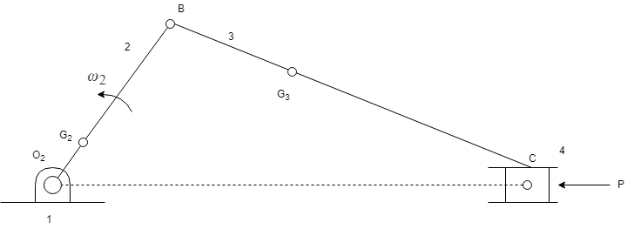

1. Configuration diagram

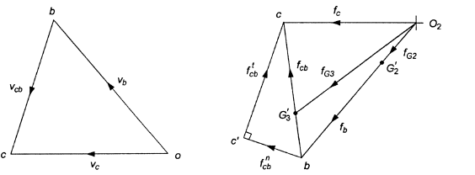

(b) velocity diagram (c) acceleration diagram

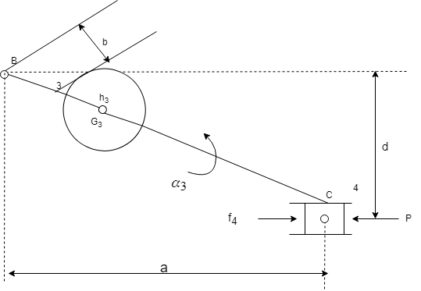

(d)

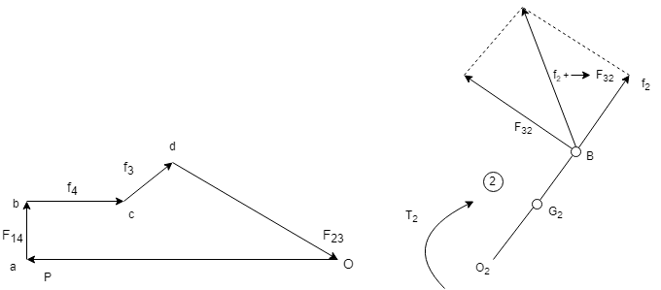

(e) (f)

**Fig. 1** Static and inertia force analysis of slider-crank mechanism

The free body diagram for link 2 is shown in [Fig.1](https://learning.oreilly.com/library/view/Theory+of+Machines/9789332528567/xhtml/chapter011.xhtml#ch11fig22), where

F12 = −(f2 parrow F32)

The torque exerted by the shaft on the crank 2 at O2 is,

T2 = −(f2 parrow F32) e

The torque exerted by the crank on the crankshaft is equal to T2 but opposite in sense to T.

SOURCE:[2] <https://www.academia.edu/37828056/Chapter_-2_DYNAMIC_FORCE_ANALYSIS>

**3. Flowchart:**

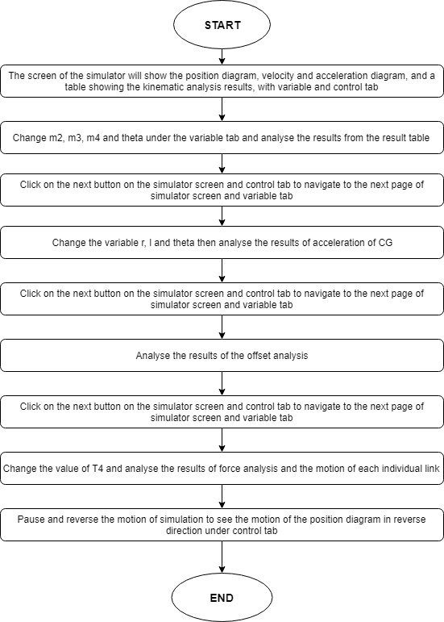

1. **Mind map:**

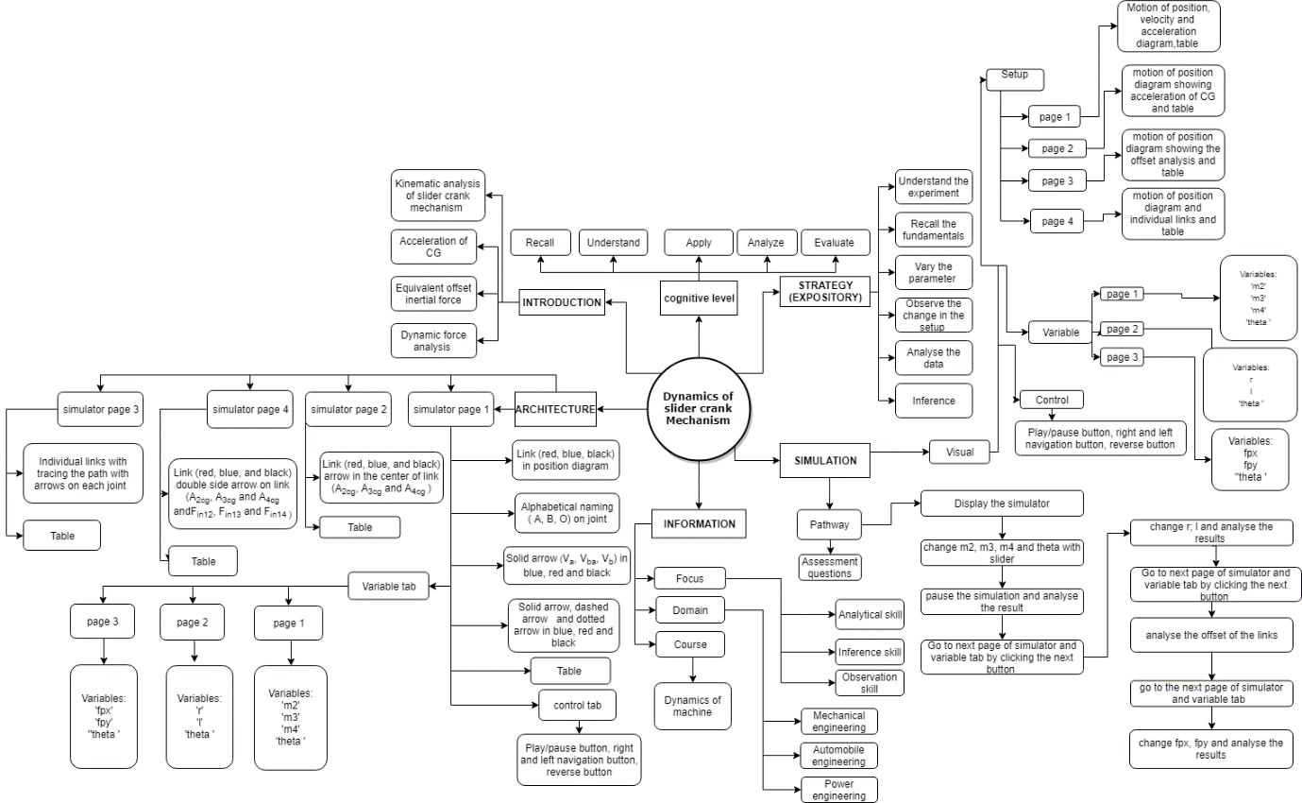

1. **Storyboard:**
   1. In simulation window the motion of position diagram, velocity and acceleration diagram is shown.
   2. There are pointers given on right side of the screen under the variable tab to change the values of m2, m3 m4 and 2, and navigation, play/pause and reverse button under control tab. Navigation buttons given on the simulator screen for the navigation of the simulator screen.

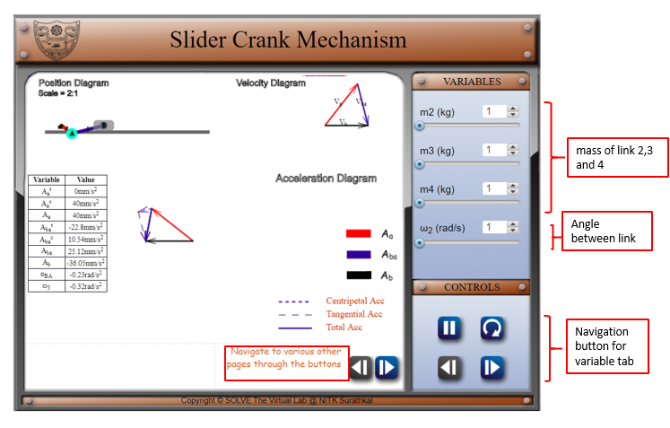

* 1. After moving on to the next page of simulator screen and variable tab, change value of r, l, and theta of the link.

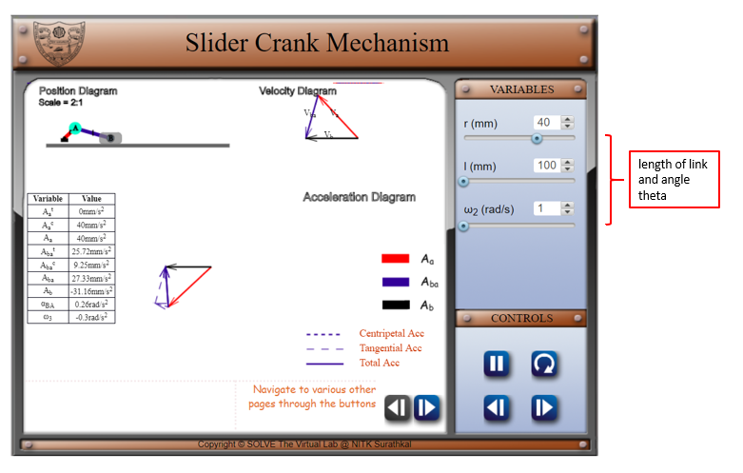

1. Navigate to the next page of the simulator screen. And analyse the offset analysis results from the table after pausing the animation,

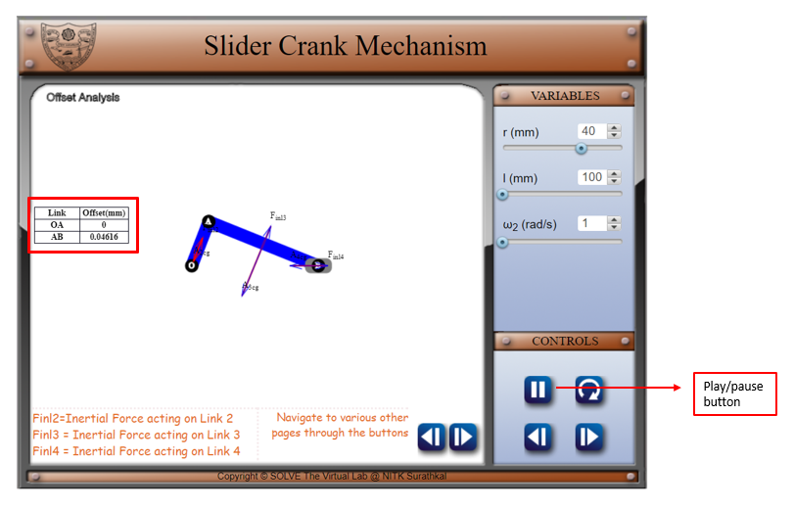

1. Navigate to the next page of simulator screen and variable tab and change fpx, fpy and reverse the animation using the control tab, then analyse the force on links.

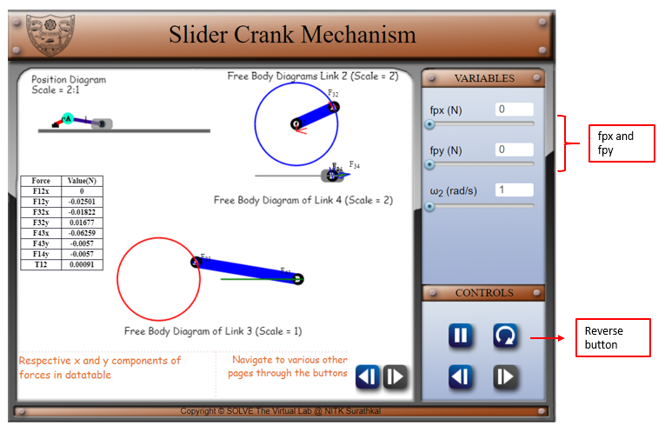

REFERENCE:

[1] Theory-of-Machines-14th-ed-Khurmi-2005 (2)

[2] <https://www.academia.edu/37828056/Chapter_-2_DYNAMIC_FORCE_ANALYSIS>